**MIGRATOry behaviour of Atlantic bluefin tuna entering the mediterranean**

Tom Carruthers[1], Antonio Di Natale[2], Matt Lauretta[3], Alfonso Pagá García2, Stasa Tensek2

*SUMMARY*

This paper shows the distribution of both conventional tags and electronic tags that were deployed in the Atlantic Ocean and in the Strait of Gibraltar when they have been recovered or popped-off in the Mediterranean Sea. For better understanding the geographical distribution of those migrant fish, it was decided to divide the Mediterranean in five different areas and then asses the presence. Most of the tags are reported from the Strait of Gibraltar, while the percentage in other areas (Med Gate, Balearic and Central Med) is lower. The lowest percentage is in the eastern Med, due to many factors, including the W-E “filter” which accounts for the accumulation of fishing activities and low tag reporting rate. It is confirmed that migrant fish are able to reach every part of the Mediterranean Sea, possibly with different abundance and with interannual variability. Further analyses of the tag data will be necessary, as well as a better reporting of natural marks, which inform us about the migration from the CS Atlantic.

*KEYWORDS*

*Electronic tagging, migration, movement, bluefin*

# Introduction

Prior to electronic tagging experiments, historical information regarding Bluefin tuna migration from the Atlantic Ocean into the Mediterranean Sea came from tuna trap fisheries which followed the seasonal reproductive migration of fish either entering the Mediterranean for spawning or those leaving after spawning (Avolio Di Paola, 1805; D’Amico, 1816; Pavesi, 1889; Parona, 1919; de Buen O., 1923, 1924a, 1924b; de Buen F., 1927a, 127b, 1931; Sella, 1929b; Rodríguez-Roda, 1964, 1965, 1966, 1983; Sarà, 1961, 1964, 1965, 1973, 1983, 1998; Scaccini, 1965; Mather *et al.*, 1995). The historical distribution of the tuna traps along most of the Mediterranean coast and the temporal sequence of their fishing activities were able to depict the sequence and seasonal timing of the migration from a realistic point of view. Additional evidence of Atlantic fish entering the Mediterranean was provided by examining the types of hooks found in Bluefin tunas caught across the Mediterranean Sea (Tunisia, northern coast of Sicily, Turkey) (Sella, 1926a, 1926b, 1927, 1929a, 1930, 1931; Heldt, 1943; Genovese, 1959).

The modern fishery no longer captures this seasonal migratory behavior since very few tuna traps continue to operate in the Mediterranean (just three, all in the SW part of Sardinia, Italy) and most catches[4] are now taken in a handful of days in the open sea in the most important spawning areas where the purse-seiners operate. While it is not clear whether the accounts arising from the historical trap are relevant to the migration of the modern population[5] in any case these are accounts largely overlooked.

Recent data collection programmes, such as those initiated and coordinated by the ICCAT GBYP (Di Natale *et al*., 2017; Sissenwine and Pearce, 2017) have provided new insights into the migratory behaviour of Atlantic bluefin tuna (*Thunnus thynnus*, L.). These include movement of individuals along the Atlantic coast of Morocco (Quilez-Badía *et al.*, 2013 a, 2013b; Di Natale and Tensek, 2015) and distant migrations to areas uninhabited since the ‘80s such as Norway or very poorly documented in recent centuries such as Greenland (Di Natale, 2012).

The conventional tag data which are stored in the ICCAT BFT tag data base have been recently quality checked and analysed for studying the growth and the large scale movements of the Bluefin tuna (Pagá García *et al*., 2017).

Electronic tagging experiments have provided invaluable information regarding the ecology, migration and stock composition of Atlantic Bluefin tuna (Block *et al*. 2005, Lutcavage *et al*. 2012, Cermeño *et al*. 2015, Tensek *et al*., in press). Electronic tagging data are now one of the principal sources of data for identifying plausible hypotheses for stock mixing and movement that may be included in Management Strategy Evaluation (MSE) to identify robust management approaches (Butterworth and Punt, 1999). Additionally, these modelling programmes can be supported by the release and recovery information arising from conventional tagging.

The data obtained in recent years from the ICCAT GBYP electronic tagging activities were provided in real time to the scientific community by the GBYP reports, but in 2016 many sets of electronic tag data, deployed by other scientists, were made available thanks to the ICCAT GBYP data recovery activities or directly by some scientists who provided the data sets for the use of the Operating Model (OM) and the Management Strategy Evaluation (MSE) developed under the GBYP as requested by the ICCAT Commission and the SCRS (Anon., 2016, 2017b).

These combined efforts resulted in a marked improvement of the data availability for the MSE in terms of Bluefin tuna movements between areas and in the various parts of its distribution range, even if the data are extremely few and sparse for the central-southern Atlantic (Di Natale *et al*., 2013). Despite the availability of the raw data, a synthesis of new knowledge was yet to be prepared by the SCRS Bluefin tuna Species Group. Scientists of the 2017 SCRS Bluefin tuna data preparatory meeting demanded an update in the current state of knowledge regarding migratory patterns for Bluefin tuna tagged in the Atlantic Ocean that subsequently moved into the various areas of the Mediterranean Sea. The purpose of this report is to provide such a synthesis.

# Methods

In this descriptive study we focus only on those conventional and electronic tags that were released in the Atlantic Ocean and the Strait of Gibraltar that subsequently entered the Mediterranean Sea. To identify different migratory behaviours, the Mediterranean Sea was divided into five areas (**Figure 1**):

* Strait of Gibraltar; the narrow gateway to the Mediterranean Sea; the exploitation rate in this area can be relatively high and therefore tagged fish are often recaptured preventing further displacement into the various Mediterranean areas.
* Med Gate; the southern part of the western Mediterranean Sea, another key passage where all fish coming from the Atlantic transit before reaching the main four spawning areas or for exiting the Mediterranean after spawning. Furthermore, this area is also one of the feeding areas for those Bluefin tuna which remains in the Mediterranean overwinter. Similarly to the Strait of Gibraltar numerous fishing activities are located in this area which can prevent further movement to other areas.
* Balearic; this area includes the true Balearic area, which is one of the four main spawning areas, but also the remaining parts of the Western Mediterranean Sea (the Catalan Sea, the Sardinian Sea, the Gulf of Lion, the Ligurian-Provençal basin and the western part of the Corsica Sea), which are important feeding areas.
* The Central Med; this very large area includes two of the most important spawning areas (the southern Tyrrhenian Sea and the central-southern Mediterranean Sea), but also other important areas for the migratory movements (the Strait of Sicily, the eastern Ionian Sea and the southern Ionian Sea) and other important areas, for juveniles distribution, for feeding and overwintering (the Gulf of Hammamet, the Gulf of Gabes, the eastern Sardinian Sea, the central and northern Tyrrhenian Sea, the Ligurian Sea, the Strait of Messina, the Adriatic Sea, the eastern Ionian Sea). The bulk of the Mediterranean catches of the Bluefin tuna are historically coming from this large area.
* The East Med; this other large area includes the last of the four main spawning areas (the Levantine Sea) and some areas where juveniles aggregate and where possibly some fish remains overwintering (the Aegean Sea, the Crete area, the Cyprus area and the Marmara Sea), due to the presence of suitable food chains. The migratory fish which are able to reach this area are those who escaped from the fishing activities in all the other four areas, therefore surely a minority fraction.

The Black Sea was not included in these area definitions despite its historical significance, since Bluefin tuna disappeared from this sea at the early beginning of the ‘80s. While there is evidence of fish slowly returning to this area (Di Natale, 2015), no tags have been recovered thus far.

A large number of both conventional and electronic tags have been released in the narrow area of the Strait of Gibraltar. In this descriptive analysis we separate these tags from those released into the Atlantic Ocean proper.

## Data

The data used for this paper are those kept by ICCAT GBYP. The conventional tag data are coming from the ICCAT Bluefin tuna tag data base, after the quality check carried out in 2016 by GBYP (Pagá García *et al*., 2017), which allows for selecting only the data having all the necessary details. The electronic tag data are those concerning the tags deployed by ICCAT GBYP and others kindly donated to the Programme.

The selection for both types of tags was based on the deployment area (**Figure 2** and **Figure 3**), excluding all tags deployed in the Mediterranean Sea. This selection allows for detecting just the migratory movements of those tunas clearly entering the Mediterranean Sea. Due to the fact that several tagging activities have been conducted also in the Strait of Gibraltar, it was decided to include these tags in the analyses.

In total we got data from 305 tags, 68 electronic tags and 237 conventional tags; 144 tags were deployed in the Atlantic and 161 tags were deployed in the Strait of Gibraltar (**Table 1**).

## Behaviours

We identified five distinct migratory behaviors for tagged fish entering the Mediterranean Sea, with movements to the:

* Strait of Gibraltar
* Med Gate
* Balearic area
* Central Med area
* East Med area
* Central Med area via the Balearic area
* Balearic area via the Central Med

Only electronic tags can provide information on the last two intra-Mediterranean movement types that help to understand mixing in the Mediterranean Sea.

# Results

Of the 62 electronic tags entering the Mediterranean Sea from the Atlantic Ocean, the majority either moved to the Med Gate area directly (36.8%) or moved to the Balearic area via the Med Gate (29.4%). Many fewer migrated to the Central Med (7.4%) and just one tag (1.5%) reached the East Med area (**Table 1**, **Figure 4**). 17.6% of the electronic tags moved to the central Med via the Balearic area, while 1.5% moved to the Balearic area via the central Med. Of the eight electronic tags entering the Mediterranean Sea from the Strait of Gibraltar, most (5 fish, 63%) migrated to the Balearic area with just one (13%) ending in the Central Med (**Table 1**, **Figure 5**). 5.9% of the electronic tags popped off in the Strait of Gibraltar.

**Figure 6** shows the heath map of the electronic tags entering the Mediterranean and it provides a sort of visual overview of the different density created by the accumulation of tracks in the various areas defined for this study.

The data concerning the conventional tags only are showed in detail on **Table 2**. Conventional tags ranked differently, with a considerable discrepancy between the tags deployed in the Atlantic and those deployed in the Strait of Gibraltar. In total, 59.1% of the conventional tags were reported from the Strait of Gibraltar (the high percentage is induced by the tags which were deployed in the same area). 17.3% of the conventional tags were recovered from the Balearic area, similarly with most ending in the Balearic area, and 14.8 from the central Med. 7.2 % were recovered from the Med Gate, while just 1.7 % reached the East Med.

# Discussion

At the beginning of the ICCAT GBYP it was decided to explore various hypotheses about a possible sub-stock structure of the eastern Atlantic Bluefin tuna within the Mediterranean Sea. A central recommendation of the SCRS and the GBYP Steering Committee was to carry out an intense multi-year set of analyses, based both on the micro-chemical and the genetic approaches to explore the various hypotheses regarding mixing and stock structure. All of these analyses which included samples from most Mediterranean areas and age classes, supported the conclusion that there was no significant differentiating pattern in the samples (Di Natale *et al*., 2017). After the discussion at the Tuna Future Symposium in Monterey (USA) in February 2016, it was decided to perform an additional experiment, by using in parallel (on the same samples) both the SNPs and the microsatellites for the genetic analyses. Even these analyses corroborated the lack of any genetic differentiation within the Mediterranean Sea (Arrizabalaga, 2017). This result counters the pre-conceptual hypotheses which were based mostly on historical descriptions of Bluefin tuna previously migrating to the Black Sea or on ideas such as the isolation of some Bluefin tuna spawners in the Balearic Sea.

Uncertainty remains over an unknown portion of so called “resident” fish (hypothetically the majority) that stay for more than one year within the Mediterranean Sea (Di Natale *et al*., 2005) (it is still unknown whether some Bluefin tuna can remain for their entire life within the Mediterranean Sea). The “resident” portion of the stock includes young of the year, juveniles and adult fish of many size classes. Historically, the adult fraction was documented through the fisheries after the spawning seasons, and they were finally electronic tagged by ICCAT GBYP in 2016, confirming the overwintering in the Mediterranean Sea. These fish usually spawn in any of the Mediterranean spawning areas alongside those migrating from the Atlantic, generating mixing among areas of the Mediterranean Sea. It is also still unknown if the fraction of migratory fish (and the correspondent fraction of “resident” fish) varies every year and to which extent, but this yearly variability is very likely to occur.

As concerns a hypothetical “spawning homing” behaviour, related to each of the spawning areas, there is no evidence to support this hypothesis so far. This is likely complicated by the ‘multi-spawning’ behavior of Bluefin tuna in which multiple spawning events can occur over several weeks up to about one month and a half (Marino *et al*., 2005, Piccinetti *et al*., 2013). These may potentially occur in more than one area over the same spawning season, further increasing the likelihood of mixing within the Mediterranean Sea. This behavior may be central to the resilience of Bluefin tuna which has persisted over the centuries to varying exploitation pressures within the Mediterranean Sea (Tinti *et al*. 2016).

According to the data we examined, we need to clearly point out that there are several additional factors to be taken into account when looking at the results. These factors are particularly important mostly for the conventional tags. The first one is the different reporting rate in the different Mediterranean areas, because, besides the many efforts done by the GBYP since the beginning of the programme, which have been already able to improve a lot the previous situation, the reporting rate is nil or almost nil in some areas and particularly in some CPCs. Having no reporting/recovery from areas where the Bluefin tuna fisheries are active clearly affects our understanding of the results and the results themselves. In some CPCs the reporting rate, even if improved compared to the past, is still clearly below a good one and this is an additional bias to be considered.

For the electronic tags, the major problems are related to premature releases, which can be caused by many factors (not accurate tagging, technological failures of the tags, etc.) and fishing events which are very difficult to duly document with the data reported by the tag, even if recently there have been improvements (Tensek *et al*., 2017).

In general terms, there is a factor that affects both the electronic and the conventional tags we examined: the increasing possibilities of a tagged fish to be fished when this fish progress from West to East inside the Mediterranean, due to the progressive higher number of fishing vessels/gears that this fish will encounter and has to survive. In an ideal word, having all necessary numbers and information, this could result in a sort of progressively decreasing “survival rate”, but unfortunately the level of available data is not enough even to roughly assess this factor.

Taking the above mentioned factors into account, the data shows us the following:

1. Most of the fish tagged in the Atlantic and in the Strait of Gibraltar (46.9%) are intercepted in the Strait of Gibraltar; the general overview is affected by the high number of fish conventionally tagged in the Strait and reported from the same area (88%), while examining the different components, a low percentage of fish tagged in the Atlantic with conventional tags are intercepted in the Strait of Gibraltar (7%); the percentage of electronic tags which popped-off in the Strait is also very low (3%). This area has an intense fishing activity and a good tag reporting/recovery rate, particularly in the northern side of the Strait.
2. The tagged fish which are showing-up in the Med Gate, an essential transit area, is relatively low (13.9%), The percentage of conventionally tagged fish in the Atlantic and in the Strait of Gibraltar which are intercepted in the Med Gate is relatively low (7.2%) compared to the high number of transit in this area. The percentage is very low for the fish tagged in the Strait of Gibraltar (3%), while it is much higher for those tagged in the Atlantic (15%); this might be due to casualties or to tunas which remains in the Strait over the time. As concerns the electronic tags, the percentage is maybe lower than initially thought (36.8%, but 42% for those fish tagged in the Atlantic). In the reality, there are several pop-ups very close to the northern boundary of the Med Gate, but slightly inside the Balearic zone and therefore these were accounted in the Balearic area. The Med Gate in general has a non-intense fishing activity and it suffers also of an extremely low tag reporting and recovery rate.
3. The number of tags (either electronic or conventional) deployed in the Atlantic and in the Strait of Gibraltar which popped-up or have been reported in the Balearic/western Mediterranean area is quite high (20%). The percentage is higher for the electronic tags (29.4%), with a very high percentage related to fish e-tagged in the Strait of Gibraltar (63%) and a low percentage for the fish e-tagged in the Atlantic (25%). The percentage is lower for the conventional tags (17.3%) particularly for the effect of those fish tagged in the Strait of Gibraltar (3%), while it is much higher for those tagged in the Atlantic (46%), for the same possible motivations reported in the previous point. The image partly changes when considering that an additional 2% of the electronic tags popped-off in the area after transiting in the Balearic area, which brings the percentage of the e-tags in this area to 30.9% and the total percentage of both types of tags to 20.3%. This area, which is a zone under the direct influence of Atlantic-origin waters, has an intense but mostly seasonal fishing activity and a reasonably good tag reporting rate.
4. The number of tags (either electronic or conventional) deployed in the Atlantic and in the Strait of Gibraltar which popped-up or have been reported in the Central Mediterranean area is moderate (13.1%), particularly when considering that the area includes two of the four main spawning areas (the southern Tyrrhenian Sea and the southern-central Mediterranean Sea). Anyway, the percentage reach about 30% of the conventional tags deployed in the Atlantic Ocean, which is quite important when considering the risk for these tunas to be fished before arriving in the Central Med. The percentage is much lower (7.4%) when considering the electronic tags. It is important to point out that the image changes a lot when considering that an additional 20% of the electronic tags popped-off in the area after transiting in the Balearic area, which brings the percentage of the e-tags in this area to 19.1% and the total percentage of both types of tags to 17.1%. The large area has an intense fishing activity and a highly variable tag reporting rate, depending on the zone and the fishery.
5. The number of tags (either electronic or conventional) deployed in the Atlantic and in the Strait of Gibraltar which popped-up or have been reported in the Eastern Mediterranean area is very low (1.6%) and this was expected. The percentage is nil for the conventional tags deployed on fish tagged in the Strait of Gibraltar, while it is around 5% for those tagged in the Atlantic, possibly for the same possible motivations reported on the above point b). The few pop-off (2%) of the electronic tags confirm anyway the interchange with the Atlantic; opposite movements from the eastern Med to the Atlantic are known as well (Di Natale *et al*., 2017). This area has an intense seasonal fishing activity in some parts but the tag reporting and recovery rates are very poor and even nil in some CPCs.

Some of the W-E “filtering” problems could be potentially (even if always partly) overcome by considerably increasing the number of electronic tags deployed on Bluefin tuna when entering in the Mediterranean, but according to the GBYP experience in the last seven years this effort will be considerably expensive and high riskily in terms of the number of spawners which will not be fished and the number of tags that will not be prematurely released. It is extremely difficult to assess the trade-off between costs/risks and increasing scientific knowledge and the balance is always arguable and questionable.

As a matter of fact, according to the current technology, this is the only way for progressively overcoming the knowledge gaps we all have about the Bluefin tuna spawning migration courses within the Mediterranean Sea, the intra-Mediterranean movements during the spawning season and overwinter for those fish which will not return back to the Atlantic, the inter-annual variability and its correlation with oceanographic and environmental aspects, and many other behavioural aspects which are important even for the stock assessment and for a more accurate management of the stock.

There are other “tags” that have been not taken into account in this work: they are the natural marks (round scars) derived from bites made by the small-tooth cookie-cutter shark (*Isistius brasilensis*) (**Figure 9** and **Figure 10**). As a matter of fact, this pelagic shark is not present in the Mediterranean Sea and it is mostly diffused in SW Atlantic. The presence of these natural marks in Bluefin tuna fished in the Mediterranean Sea is well known since decades (Arena, 1985, 1988a, 1988b; Di Natale *et al*., 2013) and it is noticed mostly on large males. The percentage of Bluefin tuna with natural marks in the Italian purse-seine catches in the ‘80s was about 2% and about 98% of these tunas with natural marks were large males. This fact poses a further doubt, about a possible different behaviour by sex of the Bluefin tuna at a given life stage or in some areas. Surely, the presence of Bluefin tunas with natural marks in the Mediterranean Sea reveals that these fish are coming from (or transited by) somewhere in the central-southern Atlantic, further complicating our understanding, due to the complete lack of recent information from this large area.

# Conclusions

Both the electronic tags and the conventional tags deployed in the Atlantic Ocean or in the Strait of Gibraltar confirms the relevance of the periodic migration of the Bluefin tuna in all areas of the Mediterranean Sea, following both the Atlantic waters entering in the Mediterranean Sea and ancient migratory routes, even if these can be opportunistically modified according to the oceanographic characteristics in every month in each year or to specific biological and ethological needs of the species.

It should be also necessary to improve the observation of natural marks in all Mediterranean Bluefin tuna fisheries, a work having no additional costs but which is considered able to provide several additional data and a broader view of the Bluefin tuna movements.

The efforts made by various scientists so far and particularly the huge effort by ICCAT GBYP in recent years clearly show the importance of the tagging activities (either electronic or conventional) for improving our knowledge about the behaviour of Bluefin tuna. As discussed in the previous chapter, we can further improve the scientific knowledge on this species only improving the tagging efforts, until new technologies will become available.

# Acknowledgements

This work was carried out under the provision of the ICCAT Atlantic Wide Research Programme for Bluefin Tuna (GBYP), funded by the European Union, several ICCAT CPCs, the ICCAT Secretariat and by other entities (see: http://www.iccat.int/GBYP/en/Budget.htm). The contents of this paper do not necessarily reflect the point of view of ICCAT or other funders and in no ways anticipate ICCAT future policy in this area.

# References

Anon. 2016, Aggregated electronic tagging data for use in operational modelling of Atlantic bluefin tuna. Available at: <https://github.com/ICCAT/abft-mse/blob/master/Data/Raw/PSAT/ALL_BFT_ElectronicTags_01122015.csv> [accessed Nov 2016]

Anon., 2017a, Bluefin tuna, ICCAT Biennial Period Report, 2016-2017, Part 1 (2016), vol. 2: 91-126.

Anon., 2017b, Report of the 2017 ICCAT SCRS Bluefin Tuna Data Preparatory Meeting. Available at: <http://iccat.int/Documents/Meetings/Docs/2017_BFT_DATA_PREP_ENG.pdf>

Arena P., 1985, La pesca del tonno in Sicilia. Atti Conv.Pesca e Trasf. Prod. Itt. Siciliani, Trapani: 23-28.

Arena P., 1988a, Risultati delle rilevazioni sulle affluenze del tonno nel Tirreno e sull’andamento della pesca da parte delle “tonnare volanti” nel triennio 1984-1986. MMM-CNR, Atti Seminari UU.OO. Resp.Prog. Ric., Roma: 273-297.

Arena P., 1988b, Rilevazioni e studi sulle affluenze del tonno nel Tirreno e sull’andamento della pesca da parte delle “tonnare volanti” nel quadriennio 1984-1988. Report to: ESPI, Ente Siciliano per la Promozione Industriale, Palermo, 1-55, I-XI.

Avolio Di Paola F., 1805, Delle Leggi Siciliane intorno alla Pesca. Reale Stamperia, Palermo : 1-239.

Arrizabalaga, H. 2017. Short term contract for biological studies ICCAT GBYP 09/2016 of the Atlantic-wide research programme on bluefin tuna. Available at: [http://www.iccat.int/GBYP /Documents/](http://www.iccat.int/GBYP%20/Documents/) BIOLOGICAL%20STUDIES/ PHASE%206/ Biological_Studies_AZTI.pdf

Block B. A., Teo S.L.H., Walli A., Boustany A., Stokesbury M.J.W., Farwell C.J., Weng K.C., Heidi D., Williams T.D., 2005, Electronic tagging and population structure of Atlantic bluefin tuna. Nature. 434: 1121-1127.

Butterworth D.S., Punt A.E., 1999, Experiences in the evaluation and implementation of management procedures. ICES J. Mar. Sci. 56, 985-998.

Cermeño P., Quilez-Badia G., Ospina-Alvarez A., Sainz-Trapaga S., Boustany A., Seitz A.C., Tudela S., Block B.A., 2015, Electronic tagging of Atlantic bluefin tuna (*Thunnus thynnus,* L.) reveals habitat use and behaviors in the Mediterranean Sea. PLoS ONE 10 (2): e0116638. doi: 0.1371/journal.pone.0116638.

D’Amico F.C., 1816, Osservazioni pratiche intorno alla pesca, corso e cammino de’ tonni. Società Tipografica, Messina: 1-164.

de Buen F., 1927a, Sobra la biología del atún, su pesca y conservación de sus carnes. Bol. Pescas, 12 (128) : 108-110.

de Buen F., 1927b, Notes et bibliographie sur la biologie du thon. Proc.-Verb. Cons. Explor. Mer., 44: 98-107.

de Buen F., 1931, El supuesto paso por el estrecho de Gibraltar del atún en su emigración genética. CIESM VI: 405-409.

de Buen O.,1923, Biología del atún. En: O. de Buen (dir.), Resultados de las campañas realizadas por acuerdos internacionales, Madrid, 1: 1-118.

de Buen O., 1924a, Las migraciones del atún en las costas Atlánticas del Sur España. Bol. Pescas, Madrid, 9 (92-93): 93-95.

de Buen O., 1924b, Les migrations du thon (*Orcynus thynnus*) sur les côtes atlantiques du Sud de l’Espagne. C.R. Acad. Sc., Paris, 178: 1104-1106.

Di Natale A., 2012, New data on the historical distribution of Bluefin tuna (*Thunnus thynnus*, L.) in the Arctic Ocean. Collect. Vol. Sci. Pap., ICCAT, 68 (1): 102-114.

Di Natale A., 2015, Revision of the historical and biological evidences about a population of Bluefin tuna (*Thunnus thynnus*, L.) in the eastern Mediterranean and in the Black Sea. Collect. Vol. Sci. Pap., ICCAT, 71 (3): 1098-1124.

Di Natale A., Idrissi M., 2012, Factors to be taken into account for a correct reading of tuna trap catch series. Collect. Vol. Sci. Pap., ICCAT, 67 (1): 242-261.

Di Natale A., Tensek S., 2016, ICCAT Atlantic-wide Research Programme for Bluefin tuna (GBYP) : Activity report for the last part of Phase 4 and the first part of Phase 5 (2014-2015). Collect. Vol. Sci. Pap., ICCAT, 72 (6): 1477-1530.

Di Natale A., Mangano A., Piccinetti C., Ciavaglia E., Celona A., 2005, Bluefin tuna (*Thunnus thynnus* L.) line fisheries in the Italian seas. Old and recent data. Collect. Vol. Sci. Pap., ICCAT, 58 (4): 1285-1295.

Di Natale A., Idrissi M., Justel Rubío A., 2013, The mistery of Bluefin tuna (*Thunnus thynnus*) presence in the South Atlantic in recent years. Collect. Vol. Sci. Pap., ICCAT, 69 (2): 857-868.

Di Natale A., Tensek S., Pagá García A., 2016, Preliminary information about the ICCAT GBYP activities in Phase 5. Collect. Vol. Sci. Pap., ICCAT, 72 (6): 1589-1613.

Di Natale A., Tensek S., Pagá García A., 2017, ICCAT Atlantic-wide Research Programme for Bluefin Tuna (GBYP). Activity report for the last part of Phase 5 and the first part of Phase 6 (2015-2016). SCRS/2016/193, Collect. Vol. Sci. Pap., ICCAT, 73 (7): 2424-2503.

Genovese S., 1959, Ami trovati in tonni (*Thunnus thynnus* L.) catturati in Sicilia e Calabria. Atti Soc.Pelor.Sc.Fis.Mat.Nat., V(4).

Heldt H., 1943, Etude sur le thon, la daurade et les muges. Histoires d’écailles et d’hameçons. Stat. Océan. Salammbô, Brochure 1 : 1-48.

Lutcavage M.E., Galuardi B., Lam T.C.H., 2012, Predicting potential Atlantic spawning grounds of western Atlantic bluefin tuna based on electronic tagging results, 2002-2011. Collect. Vol. Sci. Pap., ICCAT. 69 (2): 955-961.

Marino G., Candi G., Di Marco P., Longobardi A., Priori A., 2005, Supporto scientifico per la riproduzione controllata di grandi pelagici: *Seriola dumerilii* e *Thynnus thynnus*. ICRAM, Relazione finale VI Piano Triennale della Pesca e dell’Acquacoltura. Progetto di Ricerca 6C83.

Mather F.J.III, Mason J.M., Jones A.C., 1995, Historical document: Life History and Fisheries of Atlantic Bluefin Tuna. NOAA Tech. Mem., NMFS-SEFSC, 370: 1-165.

Pagá García A., Tensek S., Di Natale A., 2017, Bluefin tuna (*Thunnus thynnus*) growth and displacements derived from conventional tags data. SCRS/2016/143, Collect. Vol. Sci. Pap., ICCAT, 73 (6): 2150-2163.

Parona C., 1919, Il Tonno e la sua pesca. R. Comit. Talass. Ital., Venezia, Mem. LXVIII: 1-259.

Pavesi P., 1889, L’industria del Tonno. Relazione alla Commissione Reale per le Tonnare. Min. Agric. Indust. Comm., Roma, Tip. Eredi Botta: 1-254.

Piccinetti C., Di Natale A., Arena P., 2013, Eastern Bluefin tuna (*Thunnus thynnus*, L.) reproduction and reproductive areas and seasons. Collect. Vol. Sci. pap., ICCAT, 69 (2): 891-912.

Quílez-Badia G., Cermeño P., Tudela S., Sainz Trápaga S., Graupera E., 2013, Spatial movements of bluefin tuna revealed by electronic tagging in the Mediterranean Sea and in Atlantic waters of Morocco in 2011. Collect. Vol. Sci. Pap., ICCAT, 69 (1): 435-453.

Quílez-Badia G., Cermeño P., Sainz Trápaga S., Tudela S., Di Natale A., Idrissi M. Abid N., 2013, 2012 ICCAT-GBYP pop-up tagging activity, in Larache (Morocco), Collect. Vol. Sci. Pap., ICCAT, 69 (2): 869-877.

Rodriguez-Roda J., 1964, Movimientos migratorios del atun, *Thunnus thynnus* (L.), deducidos por nuestras propias “marcaciones” en aguas españolas. Publicaciones tecnicas de la junta de estudios de pesca, Direccion General de Pesca Maritima, Madrid, 3: 279-304.

Rodriguez-Roda J., 1965, Sobre las fluctuaciones en la produccion de atunes de las almadrabas sudatlanticas, Publicaciones Tecnicas de la Junta de Estudios de Pesca, Madrid. 4: 205-209.

Rodriguez-Roda J., 1966, El atún, *Thunnus thynnus* (L.), de la costa sud-atlántica de España en la campaña almadrabera del año 1964 y consideraciones sobre las fluctuaciones periódicas. Investigación Pesqueras, Barcelona, 30: 9-35.

Rodríguez-Roda, J., 1983. Lo que sabemos sobre la biología del atún. In: Ibérica, actualidad científica, número, 240: 23-26.

Sarà R., 1961, Observations systématiques sur la presence du thon dans les madragues siciliennes. Proc. Gen. Fish. Coun. Médit., 6: 41-61.

Sarà R., 1964, Données, observations et commentaires sur la présence, le comportement, les caractéristiques et les migrations des thons en Méditerranée. Proc. Gen. Fish. Coun. Medit. 7, 37: 371-388.

Sarà R., 1965, Sur la présence du thon rouge (*Thunnus thynnus*) le long des côtes d’Italie. Proc. Gen. Fish. Coun. Médit., 8:73-77.

Sarà R., 1973, Sulla biologia dei tonni (*Thunnus thynnus* L.). Modelli di migrazione ed osservazione sui meccanismi di migrazione e di comportamento. Boll. Pesca Piscic. Idrobiol., 28: 217-243.

Sarà R., 1983, Tonni e Tonnare, Una Civiltà, una Cultura. Libera Università di Trapani Ed., Trapani: 1-128.

Sarà R., 1998, Dal mito all’aliscafo. Storie di Tonni e Tonnare. Banca Aegusea Ed., Favignana-Palermo: 1-271.

Scaccini A., 1965, Biologia e pesca dei tonni nei mari italiani. Ministero Marina Mercantile, Mem. 12. 101 p.

Sella M., 1926a, Altri fatti sopra la migrazione dei tonni accertati per mezzo degli ami. Rend. Reale Accad. Dei Lincei, Roma, IV, ser.6, 2 sem.(5-6): 223-227.

Sella M., 1926b, Le migrazioni dei tonni studiate per mezzo degli ami. Atti R. Accad. Dei Lincei, Roma, III, ser.6, 1 sem.(II): 696-700.

Sella M., 1927, Les migrations des thons étudiées par le moyen des hameçons. Bull. Trav. Pub. Stat. Aquicul. Pêche, Castiglione, 2 : 101-136.

Sella M., 1929a, Migrazioni ed habitat del tonno (*Thunnus thynnus* L.) studiati col metodo degli ami, con osservazioni sull’accrescimento, sul regime delle tonnare, ecc. Mem. R. Com. Talass. Ital., 16: 3-24.

Sella M., 1929b, Biologia e pesca del tonno (*Thunnus thynnus* L.). Atti Conv. Biol. Mar. Appl. Pesca, Messina, Giugno 1928: 3-32.

Sella M., 1930, Distribution and migrations of the tuna (*Thunnus thynnus* L.) studied by the method of hooks, and other observations. Internationale Revue des gesamenten Hydrobiologie und Hydrographie, 24 (5/6): 445-466.

Sella M., 1931, The tuna (*Thunnus thynnus* L.) of the Western Atlantic. An appeal to fishermen for the collection of hooks found in tuna fish. Internationale Revue des gesamenten Hydrobiologie und Hydrographie, 25 (1/2): 46-47.

Sissenwine M., Pearce J., 2017, Second review of the ICCAT Atlantic-wide Research Programme on Bluefin tuna. ICCAT GBYP Phase 6, 2016). SCRS/2016/192, Collect. Vol. Sci. Pap., ICCAT, 73 (7): 2340-2423.

Tensek S., Di Natale A., Pagá García A., 2017, ICCAT GBYP PSAT tagging: the first five years. SCRS/2016/138, Collect. Vol. Sci. Pap., ICCAT, 73 (6): 2058-2073.

Tinti, F., Puncher, G.N., Cariani, A. 2016. Historical generic samples collected in old times in the Eastern Mediterranean Sea, in the Marmara Sea or in the Black Sea, including the genetic analysis of these samples (GBYP Project 04/2016). Available at: <http://www.iccat.int/> GBYP/ Documents/ DATA%20RECOVERY/ PHASE%205/HISTORICAL_GENETIC_REPORT_PHASE5_UNIBO.pdf

## Table 1. The frequency of movement types of electronic and conventional tags originating from the Atlantic and Strait of Gibraltar. Note that multistage movement types (e.g. ‘to central Med via Balearic’) cannot be determined from conventional tag release and recapture information.

|  |  |  |  |  |  |  |  |
| --- | --- | --- | --- | --- | --- | --- | --- |
|  | Tag type: | **Electronic** | |  | **Conventional** | | **all** |
|  | Origin: | **Atlantic** | **Strait of Gibraltar** |  | **Atlantic** | **Strait of Gibraltar** | **Total** |
|  |  | **Number of tags** | | | | | |
| **Movement type** | **To Strait of Gibraltar** | 2 | 2 |  | 6 | 134 | **144** |
| **To Med Gate** | 25 | 0 |  | 13 | 4 | **42** |
| **To Balearic** | 15 | 5 |  | 36 | 5 | **61** |
| **To Central Med** | 4 | 1 |  | 25 | 10 | **40** |
| **To Eastern Med** | 1 | 0 |  | 4 | 0 | **5** |
| **To Central Med via Balearic** | 12 | 0 |  | 0 | 0 | **12** |
| **To Balearic via Central Med** | 1 | 0 |  | 0 | 0 | **1** |
|  | **Total** | **60** | **8** |  | **84** | **153** | **305** |
|  |  | **68** | |  | **237** | |  |
|  |  |  |  |  |  |  |  |
|  |  | **Percentage by origin and type** | | | | | |
| **Movement type** | **To Strait of Gibraltar** | 3% | 25% |  | 7% | 88% | **47,2%** |
| **To Med Gate** | 42% | 0% |  | 15% | 3% | **13,8%** |
| **To Balearic** | 25% | 63% |  | 43% | 3% | **20,0%** |
| **To Central Med** | 7% | 13% |  | 30% | 7% | **13,1%** |
| **To Eastern Med** | 2% | 0% |  | 5% | 0% | **1,6%** |
| **To Central Med via Balearic** | 20% | 0% |  | 0% | 0% | **3,9%** |
| **To Balearic via Central Med** | 2% | 0% |  | 0% | 0% | **0,3%** |

**Table 2. Number and percentages of conventional tags deployed in the Atlantic Ocean and in the Strait of Gibraltar and recovered in the Strait of Gibraltar and in the Mediterranean Sea**



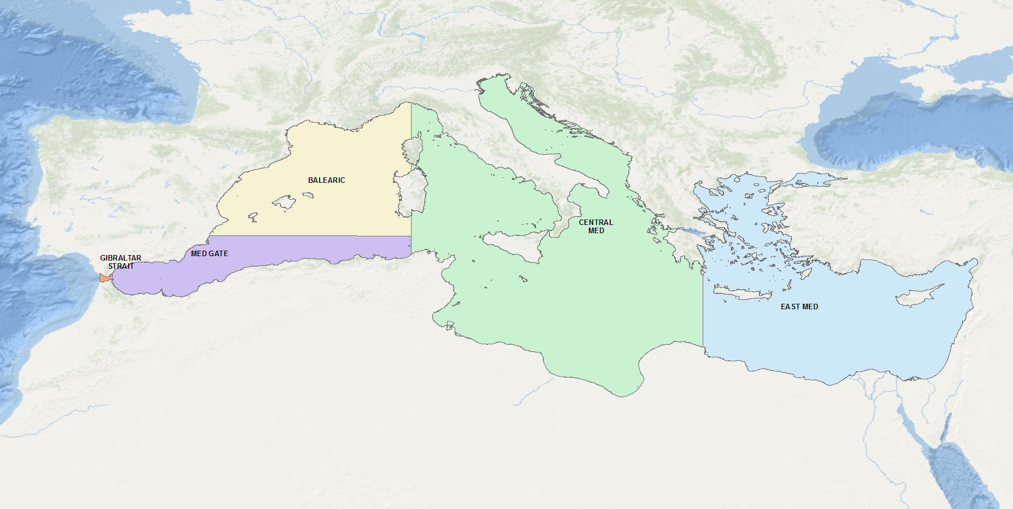

**Figure 1.**  Areas defined for studying the distribution of tags for Bluefin tunas tagged in the Atlantic which popped-off or were recovered in the various parts of the Mediterranean Sea.

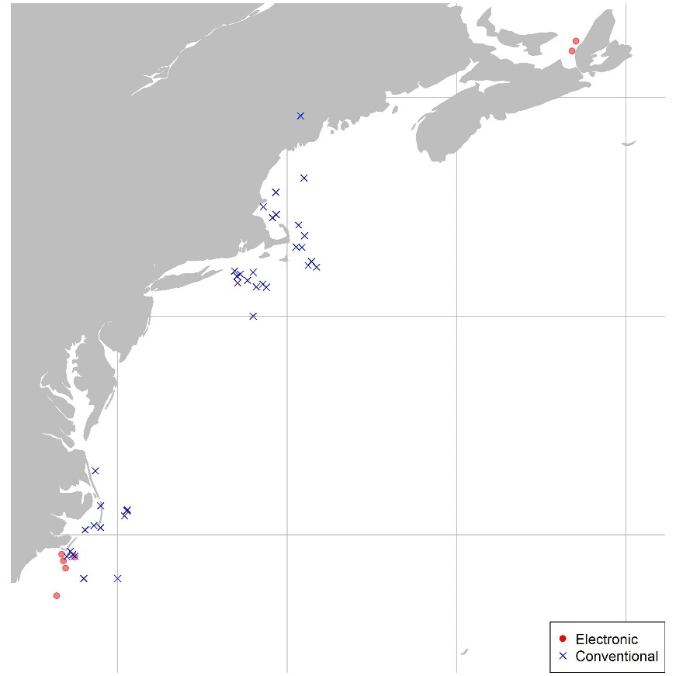

**Figure 2.** Origin (western areas) of electronic and conventional tags entering the Mediterranean

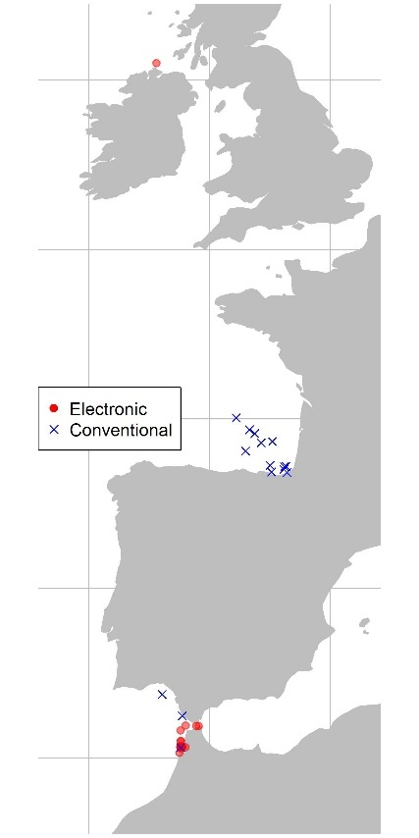

**Figure 3.** Origin (Eastern areas) of electronic and conventional tags entering the Mediterranean

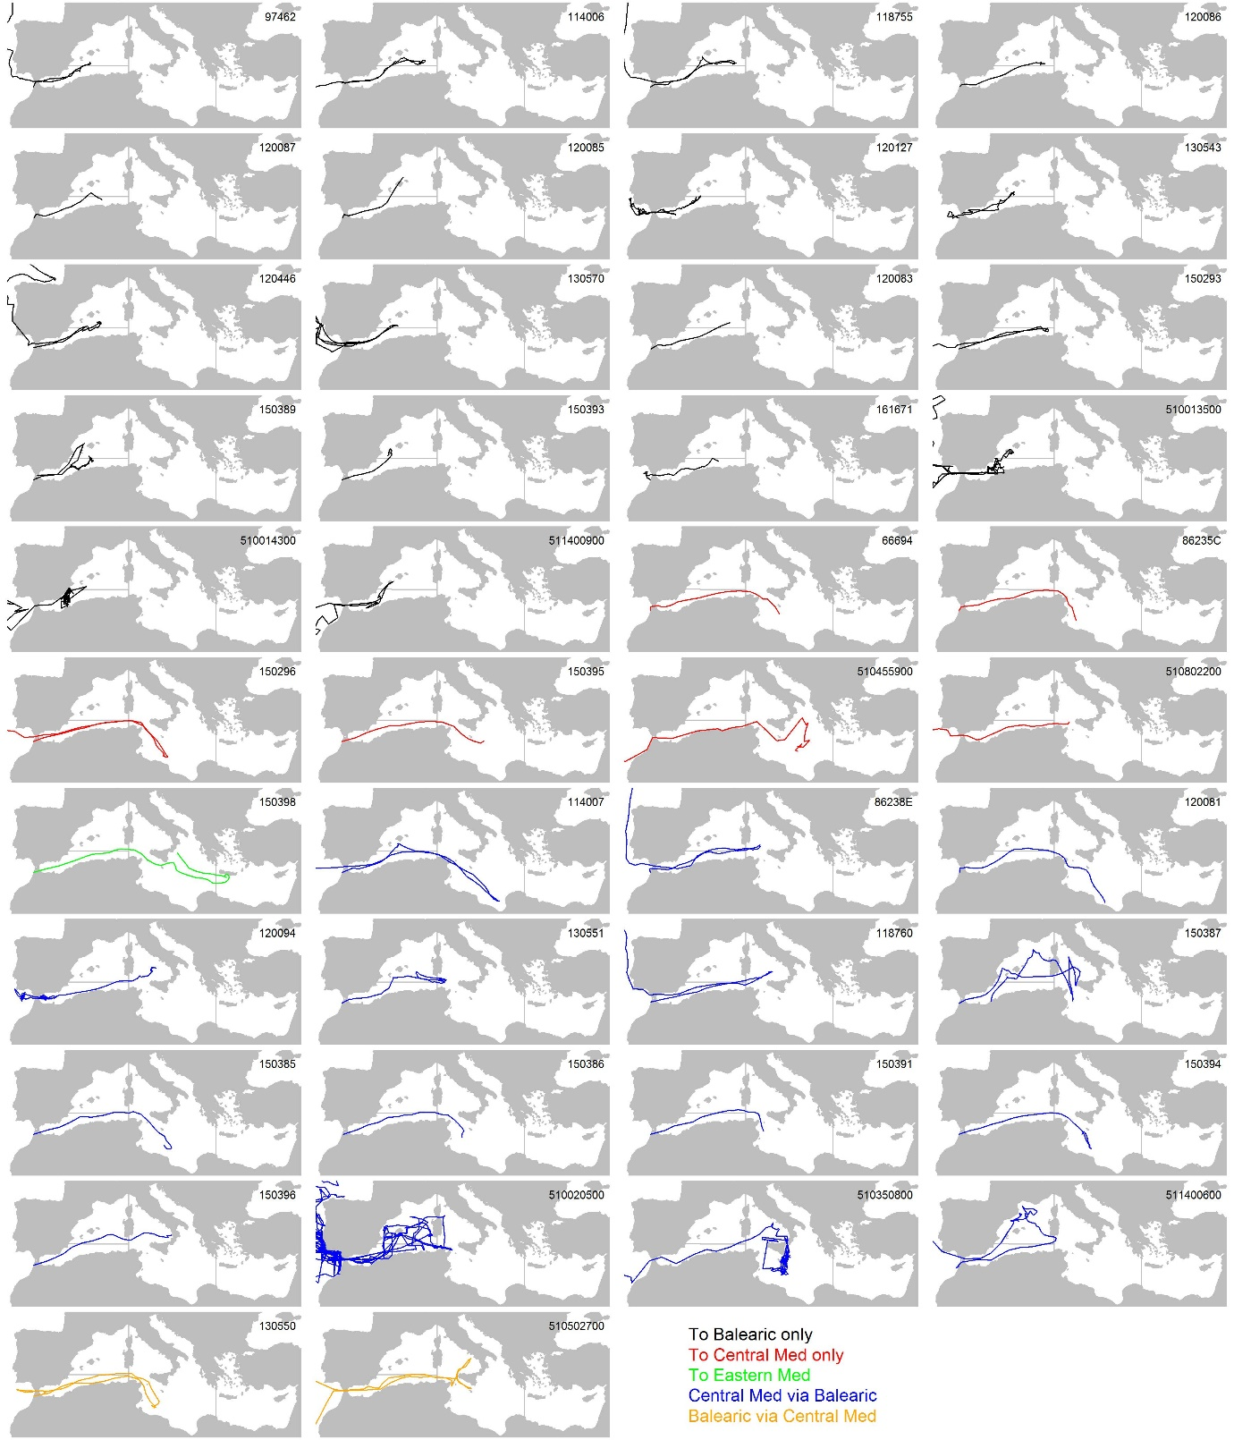

**Figure 4.** Electronic tag tracks for all tags entering the Mediterranean originating in the Atlantic organized by movement type.

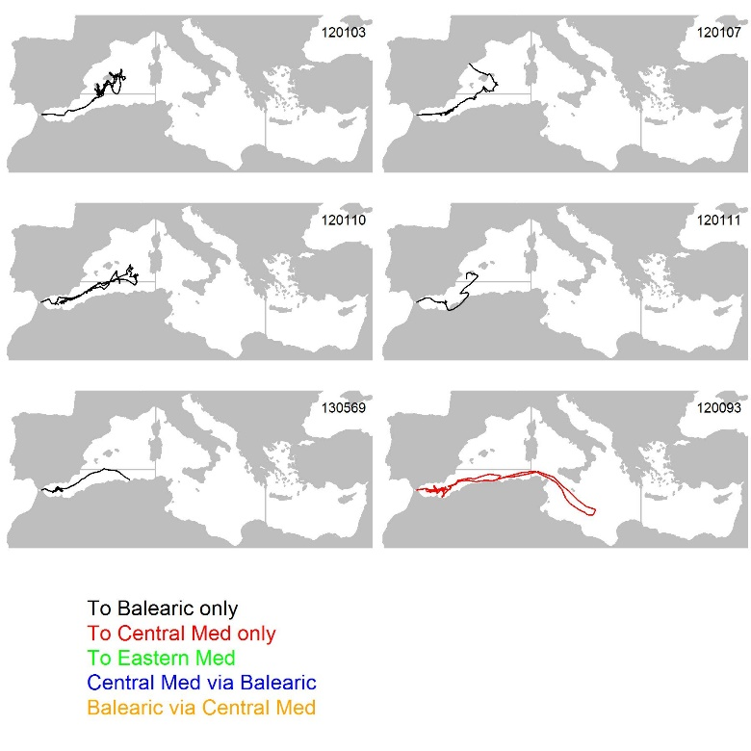

**Figure 5.** Electronic tag tracks for all tags entering the Mediterranean originating from the Strait of Gibraltar organized by movement type.

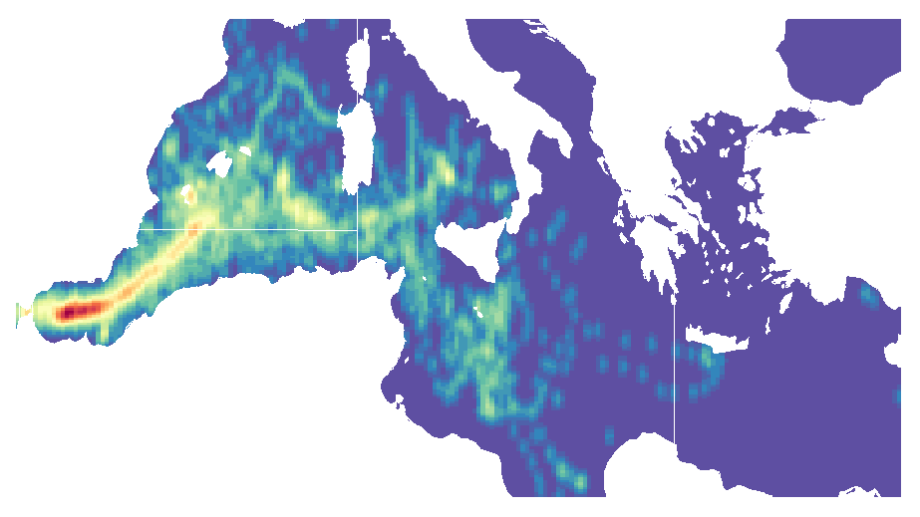**Figure 6**. Heat map of daily electronic tag density.

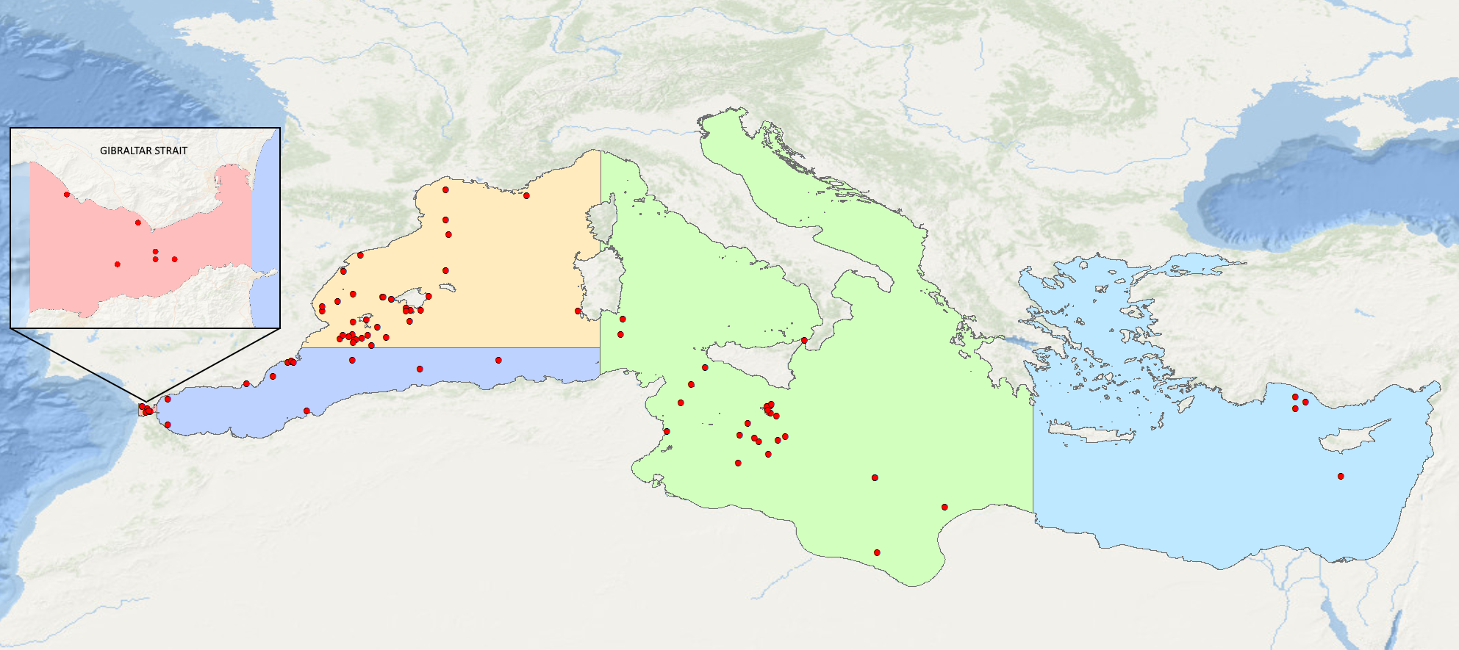

**Figure 7**. Distribution of the conventional tags deployed in the Atlantic Ocean which have been recovered in the Mediterranean Sea including the Strait of Gibraltar.

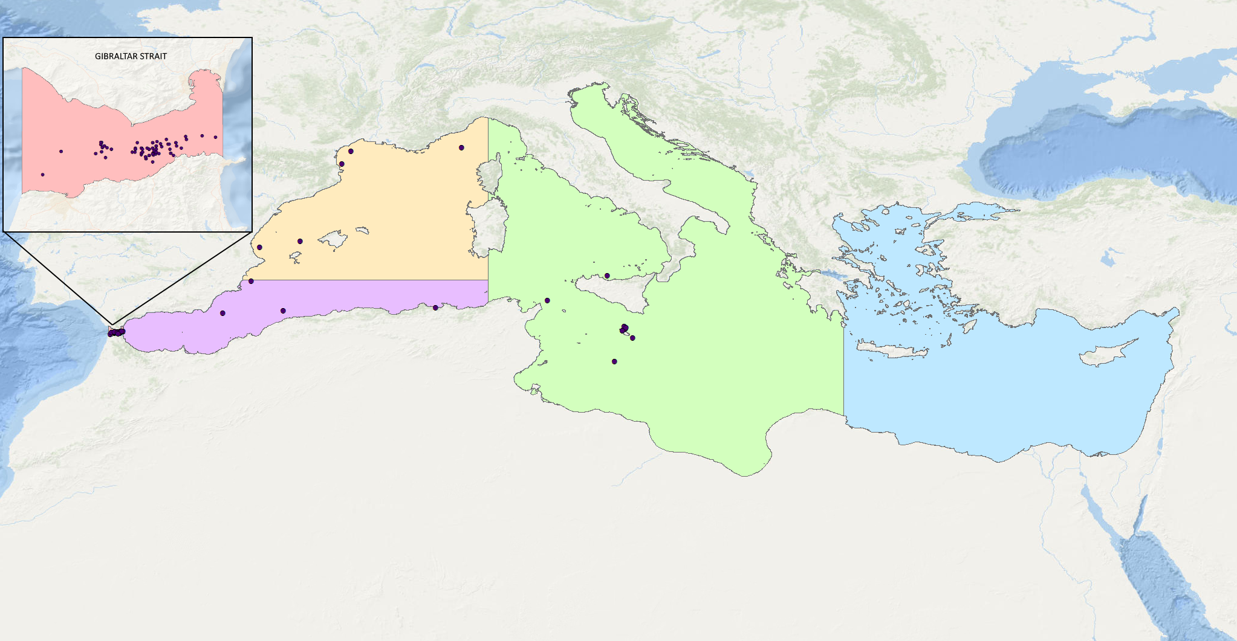

**Figure 8**. Distribution of the conventional tags deployed in the Strait of Gibraltar which have been recovered in the Mediterranean Sea and in the Strait of Gibraltar.

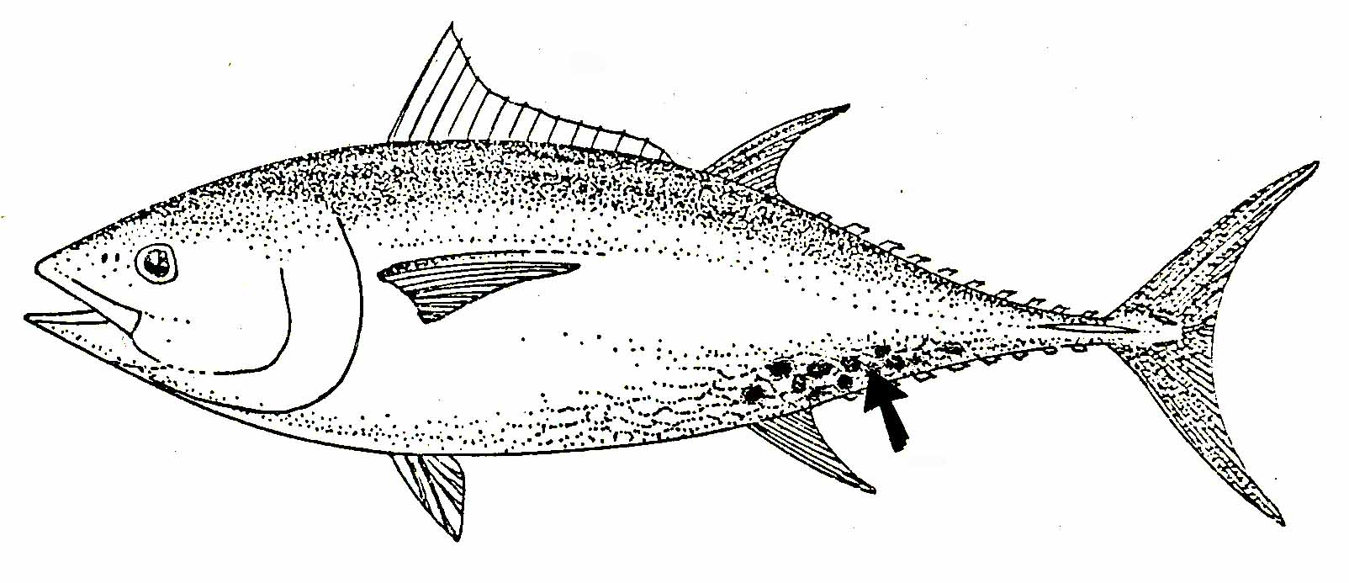

**Figure 9.** Schematic image of the preferred area where natural marks of *Isistius brasiliensiensis* usually occur on bluefin tuna.

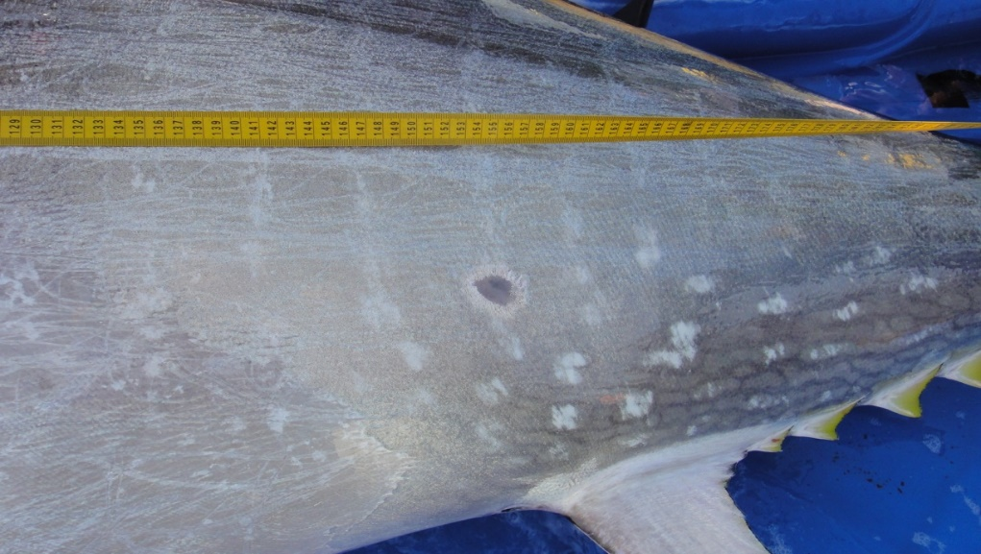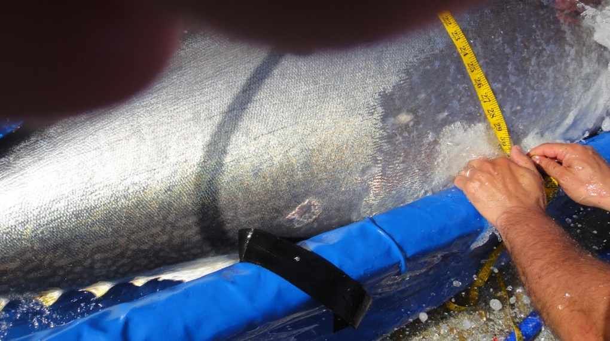

**Figure 10.** Natural marks on Bluefin tuna in the tuna trap in Larache (Morocco) in May 2012.

1. IOF, 2202 Main Mall, University of British Columbia, Vancouver, B.C., Canada, V6T 1Z4. [t.carruthers@oceans.ubc.ca](mailto:t.carruthers@oceans.ubc.ca)
2. GBYP, International Commission for the Conservation of Atlantic Tunas, ICCAT, Calle Corazón de María, 8, 28002 Madrid, Spain. [antonio.dinatale@iccat.int](mailto:antonio.dinatale@iccat.int); [alfonso.paga@iccat.int](mailto:alfonso.paga@iccat.int) ; [stasa.tensek@iccat.int](mailto:stasa.tensek@iccat.int)
3. U.S. National Marine Fisheries Service, Southeast Fisheries Center, Sustainable Fisheries Division, 75 Virginia Beach Drive, Miami, FL, 33149-1099, USA. E-mail: [matthew.lauretta@noaa.gov](mailto:matthew.lauretta@noaa.gov)
4. The Mediterranean purse-seine catches accounted for 50% to 62% of the total EBFT catches between 2011 and 2015 (Anon., 2017a, 2017b).
5. According to Di Natale and Idrissi (2012), since the beginning of the XX century and mostly in the second half of the century, the Bluefin tuna in the Mediterranean left the coastal migration in most of the areas, moving offshore to environmental changes (pollution, less transparent waters, acoustic noise, etc.).